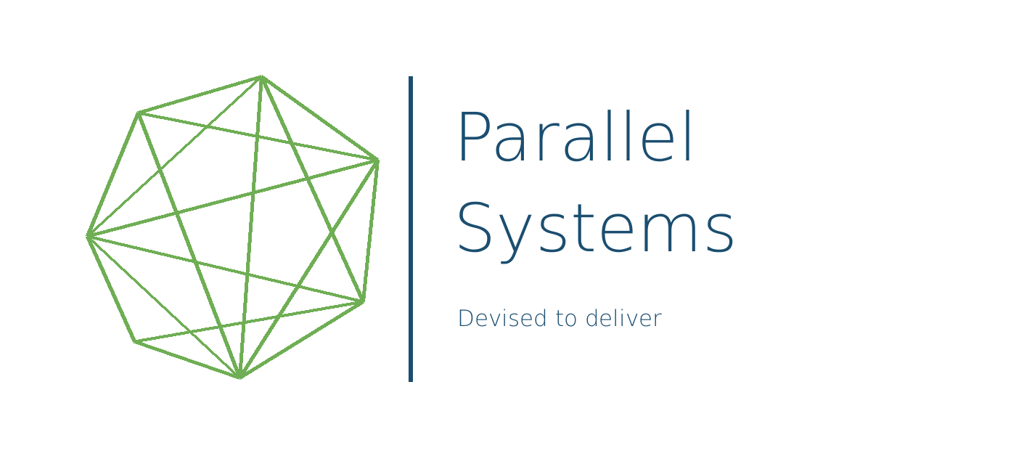
INTERNAL OPERATIONS GUIDE
ParallelSystems Development Mode
Enable protected diagnostic access for a single Revit session without starting timesheet tracking.
RESTRICTED CREDENTIAL
Password: %DevelopmentMode100%1
The password is case-sensitive and includes both % characters.

At a glance
Environment variable | PARALLEL_SYSTEMS_DEVELOPMENT_MODE=1
Activation | Password prompt when Revit starts
Authorization | Bypassed after the correct password
Timesheet tracking | Not started while Development Mode is active
Session duration | Until the current Revit process closes

What Development Mode changes
- Server authorization is bypassed for the active Revit process.
- Protected ParallelSystems commands pass their normal authorization checks.
- The timesheet tracker is not created, so no new checkpoints are created, queued, flushed, or uploaded during the session.
- A disabled DEVELOPMENT MODE ACTIVE / NO TRACKING indicator appears on the ParallelSystems ribbon.
- Closing Revit clears the in-memory password result.

Enable Development Mode
- Close every Autodesk Revit session.
- Close Visual Studio, Rider, terminals, or any other application that will launch Revit.
- Run Enable-DevelopmentMode.cmd from the Development Tools folder.
- Confirm that the command window displays Development mode enabled.
- Reopen the application used to launch Revit, if applicable, and then start Revit.
- Enter %DevelopmentMode100%1 in the Development Mode prompt.
- Select Enable Development Mode.
- Confirm that the ParallelSystems ribbon shows DEVELOPMENT MODE ACTIVE / NO TRACKING.
INCORRECT PASSWORD
The prompt remains topmost, displays an inline error, clears the password field, and allows another attempt. Select Do not enable development mode or close the prompt to continue with normal authorization.

Disable Development Mode
- Close every Autodesk Revit session.
- Close Visual Studio, Rider, terminals, or any other application used to launch Revit.
- Run Disable-DevelopmentMode.cmd from the Development Tools folder.
- Confirm that the command window displays Development mode disabled.
- Reopen the launcher application and start Revit normally.
- Verify that no Development Mode password prompt or ribbon indicator appears.

Normal operation after opting out
If the password prompt is cancelled, closed, or declined, the plugin continues with its normal server authorization flow. Timesheet tracking starts only after the user is successfully authorized.

Troubleshooting

The prompt still appears after disabling
Windows applications inherit an environment snapshot from their parent process. A running IDE, terminal, or Windows Explorer instance can retain an older value even after the user environment variable is removed.
- Close all Revit processes.
- Close the IDE or terminal that launches Revit.
- Run Disable-DevelopmentMode.cmd again.
- Reopen the launcher and start Revit.
- If the prompt still appears, sign out of Windows or restart Windows.

The prompt does not appear after enabling
- Confirm Enable-DevelopmentMode.cmd reported success.
- Confirm the variable value is exactly 1, not merely present with another value.
- Restart Revit and its launcher application after enabling the variable.
- Confirm the installed add-in is the current build containing Development Mode.

Session and security rules
- The password result is cached only in memory for the current Revit process.
- Every new Revit process requires the password again when the environment variable equals 1.
- Development Mode cannot be enabled through ApiSettings.json.
- Do not distribute this guide, its password, or the Development Tools folder to ordinary plugin users.
- Do not use Development Mode for normal production work because authorization and timesheet tracking are intentionally bypassed.
EXPECTED ACTIVE INDICATOR
DEVELOPMENT MODE ACTIVE / NO TRACKING
If this indicator is visible, the session is not performing server authorization or timesheet tracking.

